  IFRTT | REGISTRATION FORM  International Conference : HVParis’2008  (HVTT10 + ICWIM5)  19-24 May 2008  Paris Marne-la-Vallée, France |   ISWIM
Organised by : Laboratoire Central des Ponts et Chaussées (LCPC)  Hosted by : Ecole Nationale des Ponts et Chaussées (ENPC) |  |  | 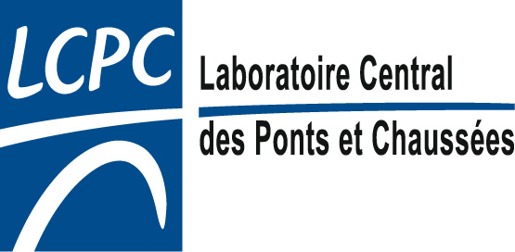  

Please complete and return this form to : LCPC, HVParis’2008
by e-mail Valerie.Fournier@lcpc.fr
or fax Fax: +33-1-40 43 65 20

Please complete the following:

Mr Mrs Dr Pr

Name First name

Organisation/Company:

We remind you that :
General registration includes the welcome cocktail, the ice-breaking buffet, the four lunches and the coffee breaks. One day registration includes the lunch and the coffee breaks.

For accompanying person the two-day tour registration includes the welcome cocktail, the ice-breaking buffet and two lunches.
The one-day tour registration includes one lunch.

Thanks to let us informed the meal(s) which you plan to take:

Welcome Cocktail (Sunday May 18 from 18.30)

Ice-breaking Buffet (Monday May 19 from 19.00)

Lunch Monday 19th Lunch Wednesday 21st
Lunch Tuesday 20th Lunch Thursday 22th

For person who have booked the conference dinner on Tuesday 20th evening, please choose:

Beef filet or Pikeperch (zander) is a Loire river fish

Are you interested in a transport pass for (to be paid In cash on site)
2 days 10 € 4 days 20 €
3 days 15 € 5 days 23 €

